**HOPKINS JUNIOR SCHOOL GANDA-NANSANA**

**END OF YEAR Examination 2022 – set i**

**CLASS: PRIMARY one**

**SUBJECT: literacy II**

**Name: ………………………………………..…………….……...…………**

1. **Listen and write.**
2. __________________________
3. __________________________
4. ______________________________________________________
5. ______________________________________________________
6. **Write words correctly.**

meit ____________________

ails _____________________

ceri_____________________

1. **Get small words form the big word below:**
2. transport _____________________, ___________________
3. weather _____________________, ___________________
4. **Form a three/four letter word from the sounds below.**

**s, p, t, o, e, a, m, n**

1. ____________________
2. ____________________
3. ____________________
4. ____________________
5. **Construct one correct sentence about each picture below.**



(a)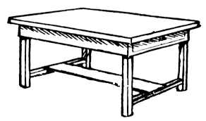___________________________________

(b)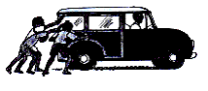____________________________________



(c)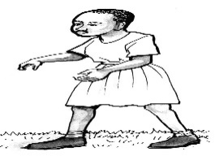 ___________________________________________

(d)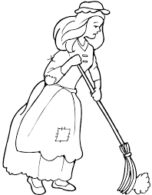_____________________________________________

1. **Write these sentences correctly.**
2. feed on Babies milk

______________________________________________________

1. has three a tree parts main

______________________________________________________

1. **Complete the riddle.**
2. I am a bird. I live in a coop. My young one is a chick. I give you eggs. What am I?___________________________________
3. I am a machine. I am in many colours. People sit inside me and I take them far. What am I?__________________________
4. I have four legs. I am found in homes, classes and offices. People sit one me. What am I? __________________________

**SECTION B (2 mks each) 60 mks**

1. **Write out four correct words from the puzzle.**
2. _____________________________
3. _____________________________
4. _____________________________
5. _____________________________

|  |  |  |  |
| --- | --- | --- | --- |
| s | i | t | e |
| i | b | i | a |
| z | a | m | s |
| e | r | e | t |
| b | e | s | t |

1. **Read the poem and answer questions about it.**

Oh ! My school

How good my school is!

Nice teachers

Good friends

Very good environment

Oh! My school

How good you are!

**By Bwanika**

**Questions**

1. Who wrote the poem?

_________________________________________________________

1. How many lines has the poem?

_________________________________________________________

1. What is the poem about?

_________________________________________________________

**Write false /true**

1. Bwanika has nice teachers

_________________________________________________________

1. Bwanika likes his school.

_________________________________________________________

1. **Choose the correct word to complete the story.**

**(red, eagle, hen, chick, eggs, white)**

My grandmother has a ______________________. It laid eight _________________and hutched them into __________________.

The chicks were ___________________in colour.

One day, an ______________________came and grabbed one of the chicks. A hen made a loud quack for its young one.

From that day grandmother decided to paint the chicks with __________________________.

1. **Rearrange the sentences to get a good story.**
2. She fell down and broke the pot.
3. One day, Angella was sent to the well.
4. On her way back home, she saw a snake.
5. She picked the pot and went to the well.

**Correct order.**

1. ______________________________________________________
2. ______________________________________________________
3. ______________________________________________________
4. ______________________________________________________
5. **Replace the first letter and form a new word.**

bat ______________ben ______________foil _______________

1. **Read the story and answer questions about it.**

**BAKING A CAKE**

One day, Jane’s mother was going to bake a cake. She called Jane for help. Mum gave Jane an apron. Then she looked at her hands. “Oh, what dirty hands you have?” Jane had long finger nails. “I must cut your finger nails short,” said Jane’s mum.

“No! No! No!” said Jane as she ran away.

**Questions**

1. Name the girl in the story.

______________________________________________________

1. Write the title of the story.

______________________________________________________

1. What was Mum going to bake?

______________________________________________________

1. Who had long nails?

______________________________________________________

1. What did mum give to Jane?

______________________________________________________

1. **Write Yes/No**
2. Mum had dirty finger nails. _________________________
3. Jane called mum for help. __________________________
4. Jane cut off her finger nails. _________________________